PROIECT BAZE DE DATE

Criveanu Andra IE

CREATE DATABASE gestiune\_vanzari;

CREATE TABLE `clienti` (

  `id\_clienti` int(7) NOT NULL,

  `nume\_clienti` varchar(50) NOT NULL,

  `prenume\_clienti` varchar(50) NOT NULL,

  `varsta\_clienti` varchar(50) NOT NULL,

  `telefon\_clienti` char(10) NOT NULL,

  `email\_clienti` varchar(50) NOT NULL,

  `oras\_clienti` varchar(50) NOT NULL,

  `judet\_clienti` varchar(50) NOT NULL,

ALTER TABLE `clienti`

ADD PRIMARY KEY (`id\_clienti`) AUTOINCREMENT;

INSERT INTO `clienti` (`id\_clienti`, `nume\_clienti`, `prenume\_clienti`, `varsta\_clienti`, `telefon\_clienti`, `email\_clienti`, `oras\_clienti`, `judet\_clienti`) VALUES ('1', 'Popescu', 'Alexandru', '27', '0765221489', 'popescualexandru99@yahoo.com', 'Slatina', 'Olt');

INSERT INTO `clienti` (`id\_clienti`, `nume\_clienti`, `prenume\_clienti`, `varsta\_clienti`, `telefon\_clienti`, `email\_clienti`, `oras\_clienti`, `judet\_clienti`) VALUES ('2', 'Eremencu', 'Ioana', '36', '0754886532', 'ioanaeremencu98@yahoo.com', 'Bucuresti', 'Bucuresti');

INSERT INTO `clienti` (`id\_clienti`, `nume\_clienti`, `prenume\_clienti`, `varsta\_clienti`, `telefon\_clienti`, `email\_clienti`, `oras\_clienti`, `judet\_clienti`) VALUES ('3', 'Andronache', 'Daniel', '34', '0721368597', 'andrdaniel78@yahoo.com', 'Timisoara', 'Timis');

INSERT INTO `clienti` (`id\_clienti`, `nume\_clienti`, `prenume\_clienti`, `varsta\_clienti`, `telefon\_clienti`, `email\_clienti`, `oras\_clienti`, `judet\_clienti`) VALUES ('4', 'Ionescu', 'George', '33', '0721356987', 'ionescugeorge@yahoo.com', 'Constanta', 'Constanta');

INSERT INTO `clienti` (`id\_clienti`, `nume\_clienti`, `prenume\_clienti`, `varsta\_clienti`, `telefon\_clienti`, `email\_clienti`, `oras\_clienti`, `judet\_clienti`) VALUES ('5', 'Constantinescu', 'Mihaela', '44', '0756913288', 'constantinescumihaela@yahoo.com', 'Craiova', 'Dolj');

INSERT INTO `clienti` (`id\_clienti`, `nume\_clienti`, `prenume\_clienti`, `varsta\_clienti`, `telefon\_clienti`, `email\_clienti`, `oras\_clienti`, `judet\_clienti`) VALUES ('6', 'Radulescu', 'Emilia', '42', '0761322589', 'radulescuemilia@yahoo.com', 'Brasov', 'Brasov');

INSERT INTO `clienti` (`id\_clienti`, `nume\_clienti`, `prenume\_clienti`, `varsta\_clienti`, `telefon\_clienti`, `email\_clienti`, `oras\_clienti`, `judet\_clienti`) VALUES ('7', 'Lica', 'Monica', '25', '0762328741', 'licamonica96@yahoo.com', 'Sibiu', 'Sibiu');

INSERT INTO `clienti` (`id\_clienti`, `nume\_clienti`, `prenume\_clienti`, `varsta\_clienti`, `telefon\_clienti`, `email\_clienti`, `oras\_clienti`, `judet\_clienti`) VALUES ('8', 'Raduica', 'Alexandru', '26', '0765231897', 'raduicaalex99@yahoo.com', 'Buzau', 'Buzau');

INSERT INTO `clienti` (`id\_clienti`, `nume\_clienti`, `prenume\_clienti`, `varsta\_clienti`, `telefon\_clienti`, `email\_clienti`, `oras\_clienti`, `judet\_clienti`) VALUES ('9', 'Iordache', 'Simona', '31', '0763214798', 'simonaiordache95@yahoo.com', 'Cluj-Napoca', 'Cluj');

INSERT INTO `clienti` (`id\_clienti`, `nume\_clienti`, `prenume\_clienti`, `varsta\_clienti`, `telefon\_clienti`, `email\_clienti`, `oras\_clienti`, `judet\_clienti`) VALUES ('10', 'Stoica', 'Rares', '28', '0762371134', 'raresstoica92@yahoo.com', 'Slatina', 'Olt');

Create table comenzi\_clienti;

`id\_comenzi` int(7) NOT NULL,

  `id\_clienti` int(7) NOT NULL,

  `data\_comenzi` date NOT NULL,

  `modplata\_comanda` varchar(50) NOT NULL

ALTER TABLE `comenzi\_clienti`

ADD PRIMARY KEY (`id\_comenzi`),

ADD KEY `id\_clienti` (`id\_clienti`);

INSERT INTO `comenzi\_clienti` (`id\_comenzi`, `id\_clienti`, `data\_comenzi`, `modplata\_comanda`) VALUES (NULL, '1', '2022-03-22', 'cash');

INSERT INTO `comenzi\_clienti` (`id\_comenzi`, `id\_clienti`, `data\_comenzi`, `modplata\_comanda`) VALUES ('2', '2', '2022-01-18', 'cash');

INSERT INTO `comenzi\_clienti` (`id\_comenzi`, `id\_clienti`, `data\_comenzi`, `modplata\_comanda`) VALUES ('3', '3', '2021-12-14', 'card');

INSERT INTO `comenzi\_clienti` (`id\_comenzi`, `id\_clienti`, `data\_comenzi`, `modplata\_comanda`) VALUES ('4', '4', '2022-05-22', 'card');

INSERT INTO `comenzi\_clienti` (`id\_comenzi`, `id\_clienti`, `data\_comenzi`, `modplata\_comanda`) VALUES ('5', '5', '2022-03-08', 'cash');

INSERT INTO `comenzi\_clienti` (`id\_comenzi`, `id\_clienti`, `data\_comenzi`, `modplata\_comanda`) VALUES ('6', '6', '2022-04-20', 'cash');

INSERT INTO `comenzi\_clienti` (`id\_comenzi`, `id\_clienti`, `data\_comenzi`, `modplata\_comanda`) VALUES ('7', '7', '2021-11-16', 'cash');

INSERT INTO `comenzi\_clienti` (`id\_comenzi`, `id\_clienti`, `data\_comenzi`, `modplata\_comanda`) VALUES ('7', '7', '2021-11-16', 'cash');

INSERT INTO `comenzi\_clienti` (`id\_comenzi`, `id\_clienti`, `data\_comenzi`, `modplata\_comanda`) VALUES ('9', '9', '2022-02-28', 'cash');

INSERT INTO `comenzi\_clienti` (`id\_comenzi`, `id\_clienti`, `data\_comenzi`, `modplata\_comanda`) VALUES ('10', '10', '2021-10-20', 'cash');

CREATE TABLE `comenzi\_produse` (

  `id\_comanda` int(7) NOT NULL,

  `id\_comenzi` int(7) AUTO-INCREMENT;

Id\_comanda PK AUTO-INCREMENT;

Id\_comenzi FOREIGN KEY;

Create table furnizori;

CREATE TABLE `furnizori` (

  `id\_furnizori` int(7) NOT NULL, PK

  `nume\_furnizori` varchar(50) NOT NULL,

  `oras\_furnizori` varchar(50) NOT NULL,

  `judet\_furnizori` varchar(50) NOT NULL

ALTER TABLE `furnizori`

  MODIFY `id\_furnizori` int(7) NOT NULL AUTO\_INCREMENT,

INSERT INTO `furnizori` (`id\_furnizori`, `nume\_furnizori`, `oras\_furnizori`, `judet\_furnizori`) VALUES ('1', 'Jacobs', 'Bucuresti', 'Bucuresti');

INSERT INTO `furnizori` (`id\_furnizori`, `nume\_furnizori`, `oras\_furnizori`, `judet\_furnizori`) VALUES ('2', 'Milka', 'Bucuresti', 'Bucuresti');

INSERT INTO `furnizori` (`id\_furnizori`, `nume\_furnizori`, `oras\_furnizori`, `judet\_furnizori`) VALUES ('3', 'Julius Meinl', 'Sibiu', 'Sibiu');

INSERT INTO `furnizori` (`id\_furnizori`, `nume\_furnizori`, `oras\_furnizori`, `judet\_furnizori`) VALUES ('4', 'Coca-Cola', 'Bucuresti', 'Bucuresti');

INSERT INTO `furnizori` (`id\_furnizori`, `nume\_furnizori`, `oras\_furnizori`, `judet\_furnizori`) VALUES ('5', 'Coco Rico', 'Brasov', 'Brasov');

INSERT INTO `furnizori` (`id\_furnizori`, `nume\_furnizori`, `oras\_furnizori`, `judet\_furnizori`) VALUES ('6', 'Napolact', 'Cluj-Napoca', 'Cluj');

INSERT INTO `furnizori` (`id\_furnizori`, `nume\_furnizori`, `oras\_furnizori`, `judet\_furnizori`) VALUES ('7', 'Fanta', 'Bucuresti', 'Bucuresti');

INSERT INTO `furnizori` (`id\_furnizori`, `nume\_furnizori`, `oras\_furnizori`, `judet\_furnizori`) VALUES ('8', 'Lays', 'Bucuresti', 'Bucuresti');

INSERT INTO `furnizori` (`id\_furnizori`, `nume\_furnizori`, `oras\_furnizori`, `judet\_furnizori`) VALUES ('9', 'Tchibo', 'Bucuresti', 'Bucuresti');

INSERT INTO `furnizori` (`id\_furnizori`, `nume\_furnizori`, `oras\_furnizori`, `judet\_furnizori`) VALUES ('10', 'Orbit', 'Bucuresti', 'Bucuresti');

Create table produse;

REATE TABLE `produse` (

  `id\_produse` int(7) NOT NULL,

  `id\_furnizori` int(7) NOT NULL,

  `descriere\_produse` text NOT NULL,

  `pret\_produse` int(7) NOT NULL

Id\_produse PK AUTO-INCREMENT;

Id\_furnizori FOREIGN KEY(INDEX)

INSERT INTO `produse` (`id\_produse`, `id\_furnizori`, `descriere\_produse`, `pret\_produse`) VALUES ('1', '1', 'cafea Jacobs macinata sau boabe', '80');

INSERT INTO `produse` (`id\_produse`, `id\_furnizori`, `descriere\_produse`, `pret\_produse`) VALUES ('2', '2', 'Ciocolata Milka cu nuci,amaruie,ciocolata alba,cu diverse arome cum ar fi capsuni,fragi,mure', '15');

INSERT INTO `produse` (`id\_produse`, `id\_furnizori`, `descriere\_produse`, `pret\_produse`) VALUES ('3', '3', 'zahar brun sau alb', '25');

INSERT INTO `produse` (`id\_produse`, `id\_furnizori`, `descriere\_produse`, `pret\_produse`) VALUES ('4', '4', 'Coca Cola cu lamaie sau diverse arome la 2L sau 1L', '8.5');

INSERT INTO `produse` (`id\_produse`, `id\_furnizori`, `descriere\_produse`, `pret\_produse`) VALUES (NULL, '5', 'pui fraged de tara Coco-Rico la 2kg', '45');

INSERT INTO `produse` (`id\_produse`, `id\_furnizori`, `descriere\_produse`, `pret\_produse`) VALUES ('6', '6', 'Napolact branza proaspata de vaca', '58');

INSERT INTO `produse` (`id\_produse`, `id\_furnizori`, `descriere\_produse`, `pret\_produse`) VALUES ('7', '7', 'Fanta de portocale la 2L', '9');

INSERT INTO `produse` (`id\_produse`, `id\_furnizori`, `descriere\_produse`, `pret\_produse`) VALUES ('8', '8', 'Lays chipsuri cu cascaval,sare', '7');

INSERT INTO `produse` (`id\_produse`, `id\_furnizori`, `descriere\_produse`, `pret\_produse`) VALUES ('9', '9', 'cafea macinata sau boabe', '98');

INSERT INTO `produse` (`id\_produse`, `id\_furnizori`, `descriere\_produse`, `pret\_produse`) VALUES ('10', '10', 'guma de mestecat cu diverse arome Orbit', '3.5');

OPERATIA DE SORTARE

[SELECT](http://localhost/phpmyadmin/url.php?url=https://dev.mysql.com/doc/refman/8.0/en/select.html) \* FROM `clienti` ORDER BY `nume\_clienti` ASC;

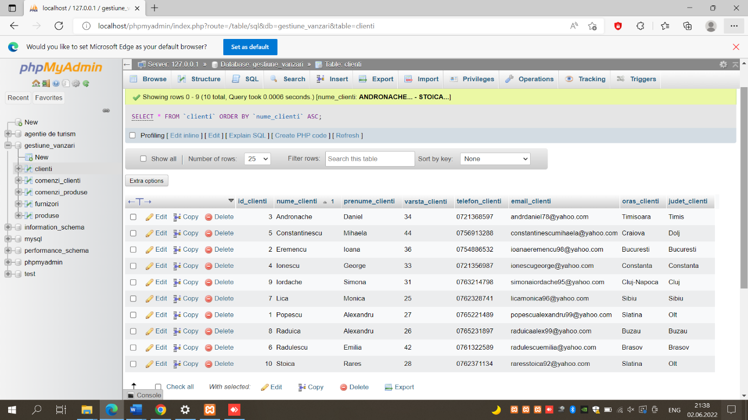

[SELECT](http://localhost/phpmyadmin/url.php?url=https://dev.mysql.com/doc/refman/8.0/en/select.html) \* FROM `clienti` ORDER BY `oras\_clienti` DESC;

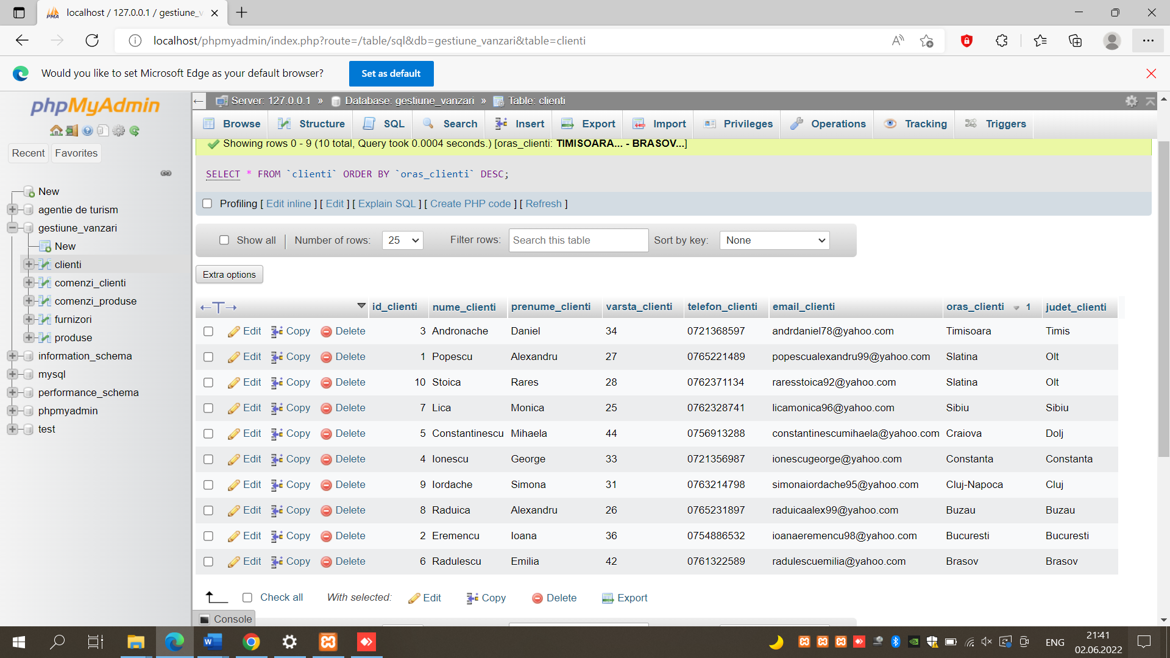

[SELECT](http://localhost/phpmyadmin/url.php?url=https://dev.mysql.com/doc/refman/8.0/en/select.html) \* FROM `clienti` ORDER BY `nume\_clienti` DESC;

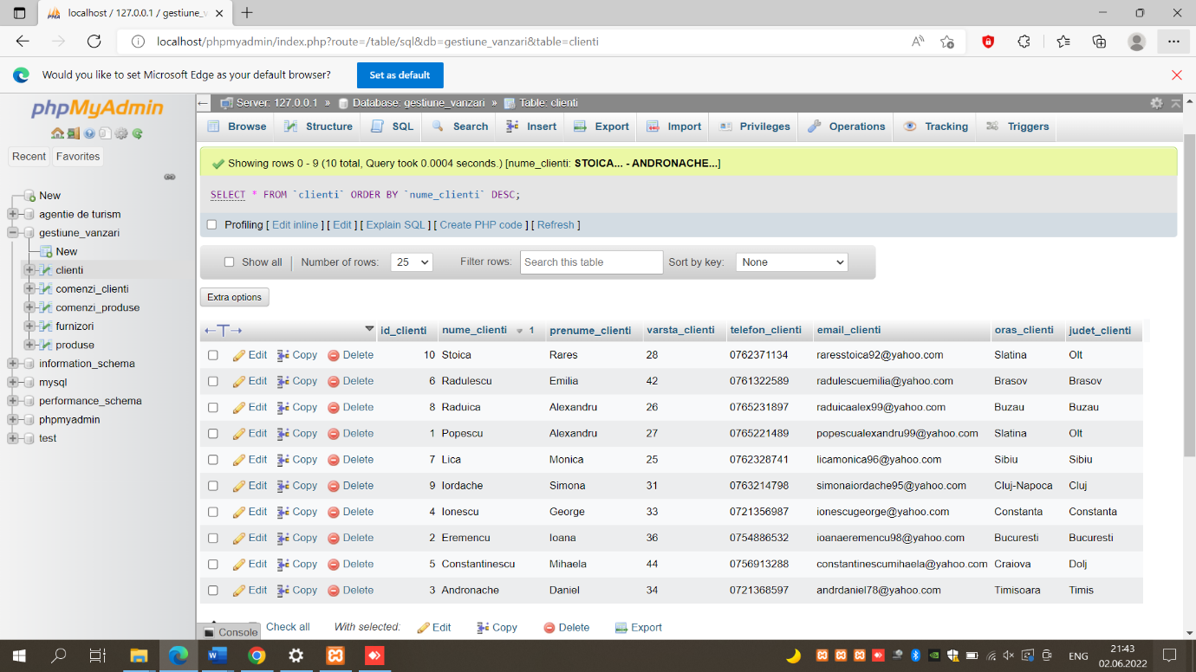

OPERATIA DE FILTRARE A REZULTATELOR:

[SELECT](http://localhost/phpmyadmin/url.php?url=https://dev.mysql.com/doc/refman/8.0/en/select.html) `descriere\_produse` FROM `produse` WHERE `descriere\_produse` [LIKE](http://localhost/phpmyadmin/url.php?url=https://dev.mysql.com/doc/refman/8.0/en/string-comparison-functions.html%23operator_like) '%ca%';

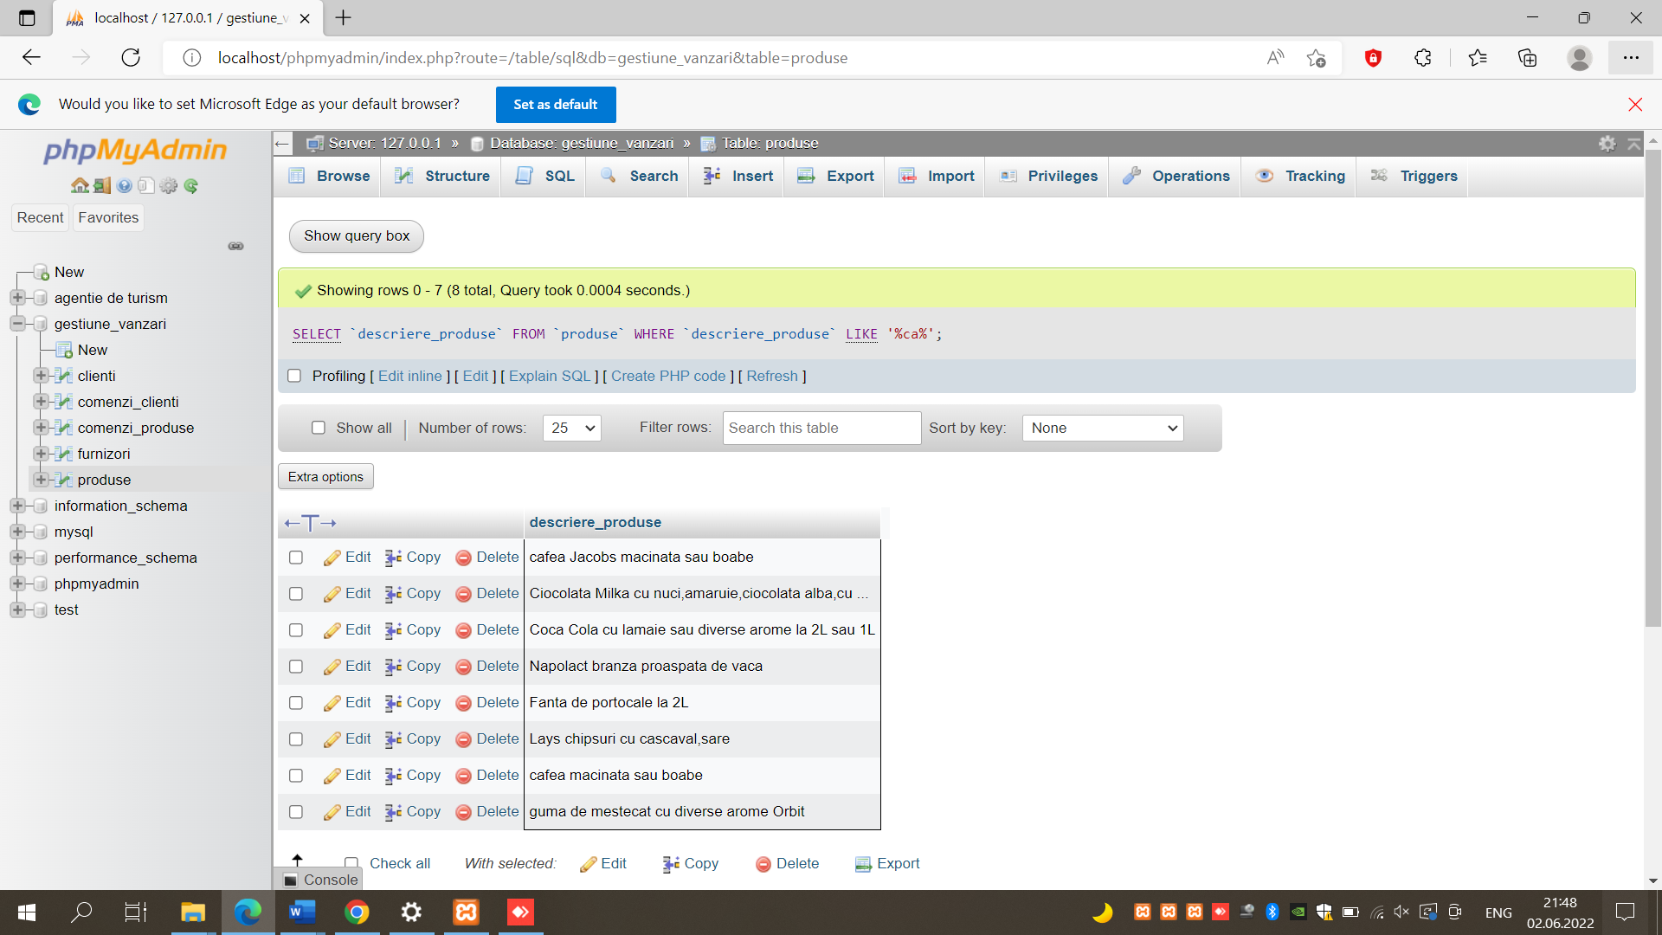

[SELECT](http://localhost/phpmyadmin/url.php?url=https://dev.mysql.com/doc/refman/8.0/en/select.html) `oras\_clienti` FROM `clienti` WHERE `nume\_clienti`= 'POPESCU';

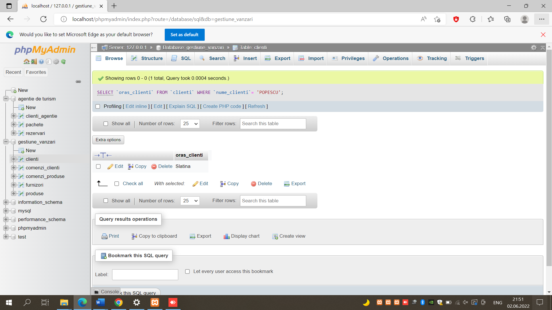

PSEUDONIME PENTRU FILTRARE;

[SELECT](http://localhost/phpmyadmin/url.php?url=https://dev.mysql.com/doc/refman/8.0/en/select.html) `nume\_clienti` AS NUME,`prenume\_clienti` AS PRENUME,`judet\_clienti` FROM `clienti`;

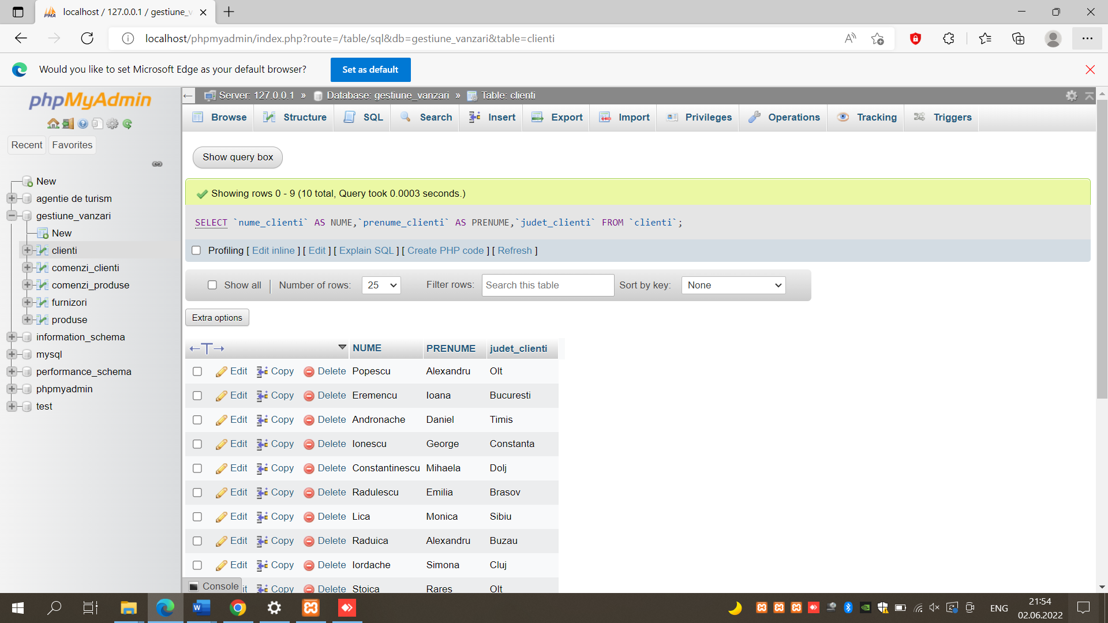

COMPARARE;

[SELECT](http://localhost/phpmyadmin/url.php?url=https://dev.mysql.com/doc/refman/8.0/en/select.html) `pret\_produse` AS PRET, `id\_produse` FROM `produse` WHERE `pret\_produse` = '98';

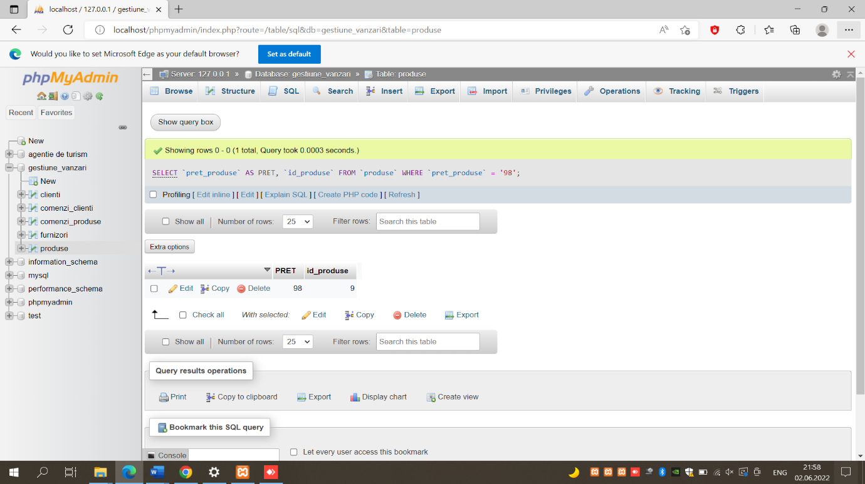

MAX,AVG,MIN;

[SELECT](http://localhost/phpmyadmin/url.php?url=https://dev.mysql.com/doc/refman/8.0/en/select.html) [max](http://localhost/phpmyadmin/url.php?url=https://dev.mysql.com/doc/refman/8.0/en/aggregate-functions.html%23function_max" \t "mysql_doc)(`pret\_produse`) from `produse`;

[SELECT](http://localhost/phpmyadmin/url.php?url=https://dev.mysql.com/doc/refman/8.0/en/select.html) [avg](http://localhost/phpmyadmin/url.php?url=https://dev.mysql.com/doc/refman/8.0/en/aggregate-functions.html%23function_avg" \t "mysql_doc)(`pret\_produse`) from `produse`;

[SELECT](http://localhost/phpmyadmin/url.php?url=https://dev.mysql.com/doc/refman/8.0/en/select.html) [min](http://localhost/phpmyadmin/url.php?url=https://dev.mysql.com/doc/refman/8.0/en/aggregate-functions.html%23function_min)(`pret\_produse`) from `produse`;

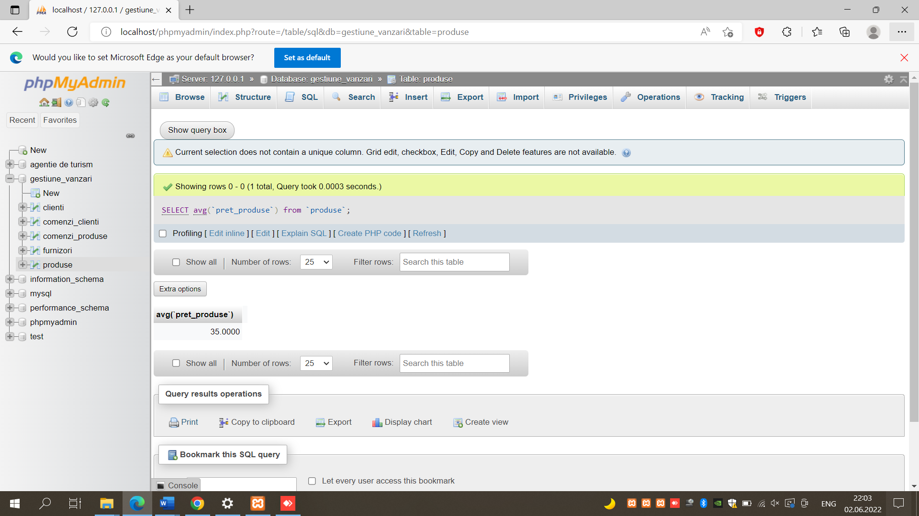

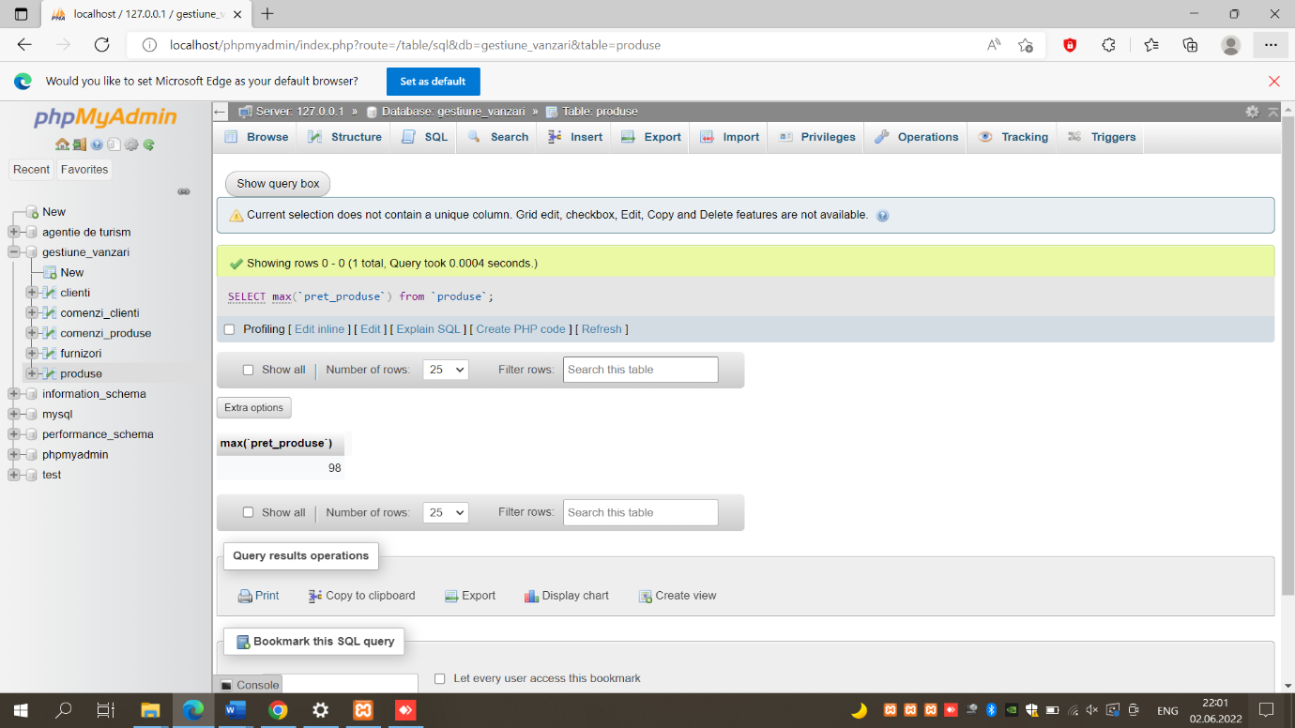

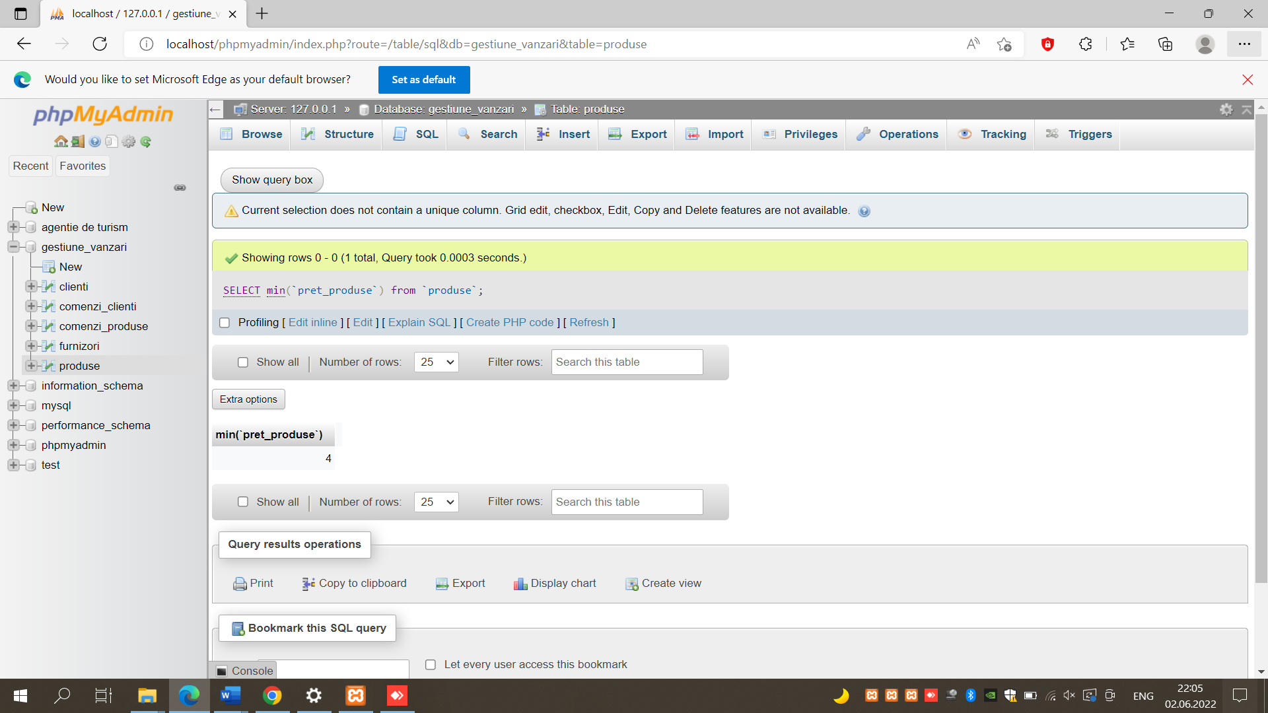

INNER JOIN;

[SELECT](http://localhost/phpmyadmin/url.php?url=https://dev.mysql.com/doc/refman/8.0/en/select.html) nume\_clienti, oras\_clienti from clienti inner join comenzi\_clienti;

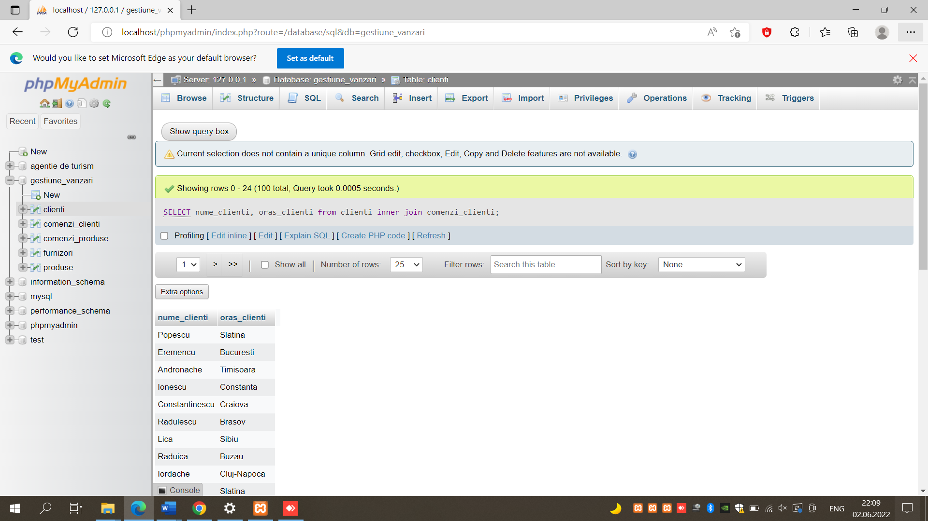

INNER LEFT:

[SELECT](http://localhost/phpmyadmin/url.php?url=https://dev.mysql.com/doc/refman/8.0/en/select.html) nume\_clienti, data\_comenzi FROM comenzi\_clienti NATURAL [LEFT](http://localhost/phpmyadmin/url.php?url=https://dev.mysql.com/doc/refman/8.0/en/string-functions.html%23function_left) JOIN clienti;

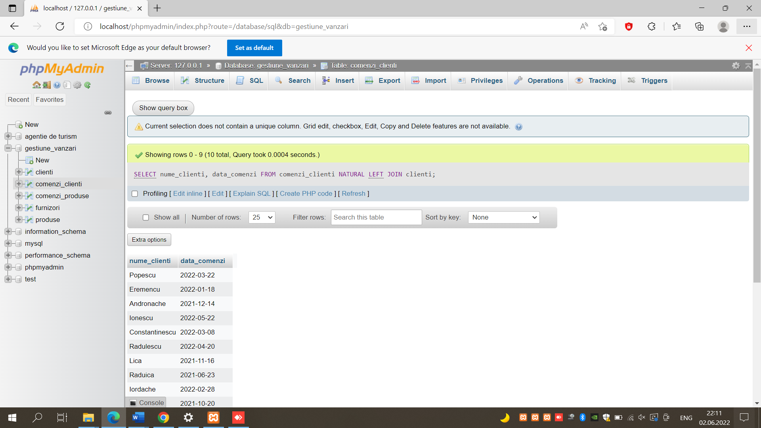

INTEROGARI AVANSATE:

FUNCTIA SQRT:

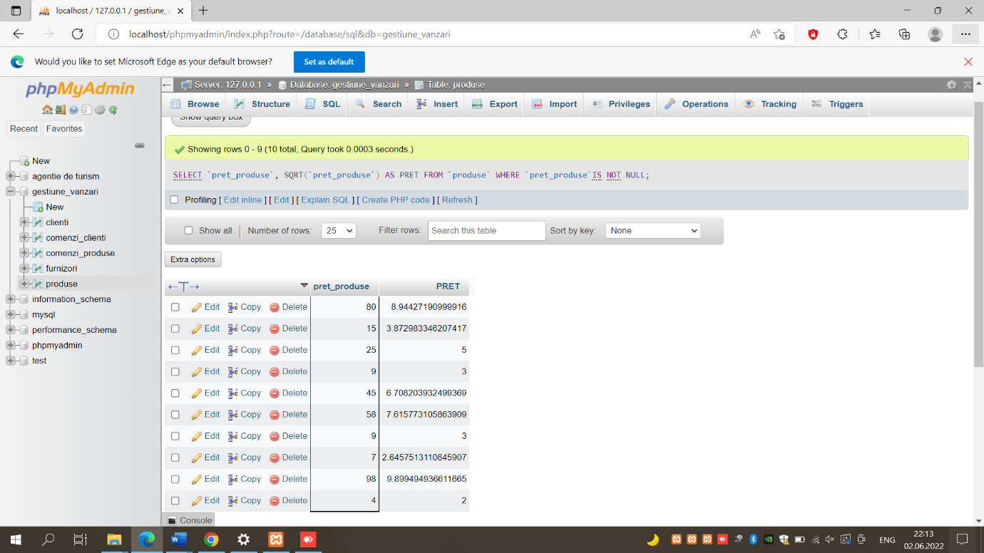[SELECT](http://localhost/phpmyadmin/url.php?url=https://dev.mysql.com/doc/refman/8.0/en/select.html) `pret\_produse`, SQRT(`pret\_produse`) AS PRET FROM `produse` WHERE `pret\_produse`[IS](http://localhost/phpmyadmin/url.php?url=https://dev.mysql.com/doc/refman/8.0/en/comparison-operators.html%23operator_is) [NOT](http://localhost/phpmyadmin/url.php?url=https://dev.mysql.com/doc/refman/8.0/en/logical-operators.html%23operator_not) NULL;

FUNCTIA REPLACE:

[SELECT](http://localhost/phpmyadmin/url.php?url=https://dev.mysql.com/doc/refman/8.0/en/select.html) TELEFON\_CLIENTI, [REPLACE](http://localhost/phpmyadmin/url.php?url=https://dev.mysql.com/doc/refman/8.0/en/replace.html) (TELEFON\_CLIENTI,'-','.') AS TELEFON FROM CLIENTI;

FUNCTIA CEILING:

[SELECT](http://localhost/phpmyadmin/url.php?url=https://dev.mysql.com/doc/refman/8.0/en/select.html) `pret\_produse` , CEILING(`pret\_produse`) AS PRET\_CEILING FROM `produse` WHERE `pret\_produse` [IS](http://localhost/phpmyadmin/url.php?url=https://dev.mysql.com/doc/refman/8.0/en/comparison-operators.html%23operator_is) [NOT](http://localhost/phpmyadmin/url.php?url=https://dev.mysql.com/doc/refman/8.0/en/logical-operators.html%23operator_not) NULL;

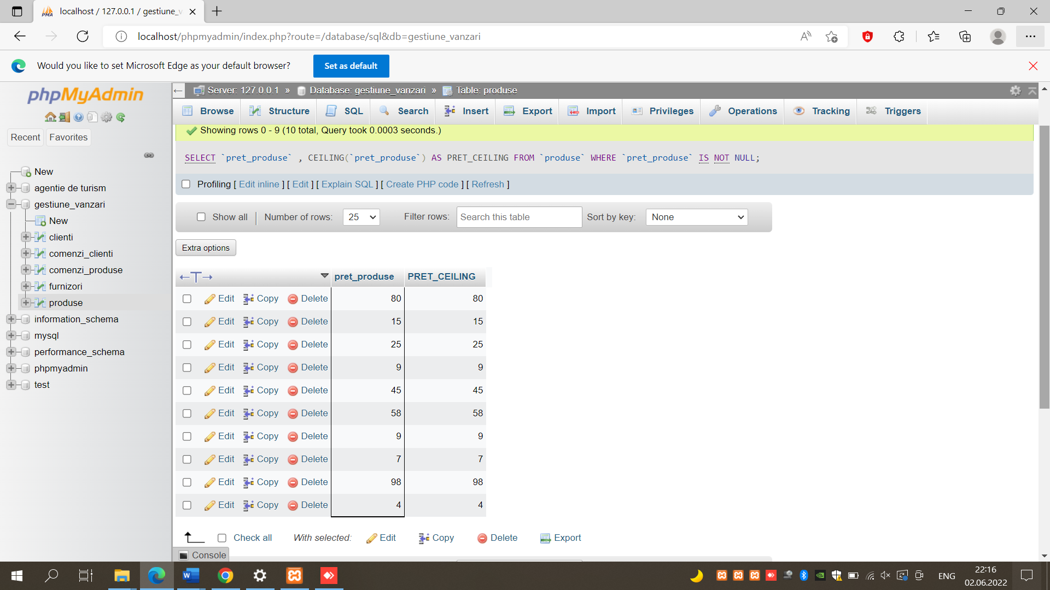

FUNCTIA FLOOR:

[SELECT](http://localhost/phpmyadmin/url.php?url=https://dev.mysql.com/doc/refman/8.0/en/select.html) `pret\_produse`, FLOOR(`pret\_produse`) AS PRET\_FLOOR FROM `produse` WHERE `pret\_produse` [IS](http://localhost/phpmyadmin/url.php?url=https://dev.mysql.com/doc/refman/8.0/en/comparison-operators.html%23operator_is) [NOT](http://localhost/phpmyadmin/url.php?url=https://dev.mysql.com/doc/refman/8.0/en/logical-operators.html%23operator_not) NULL;

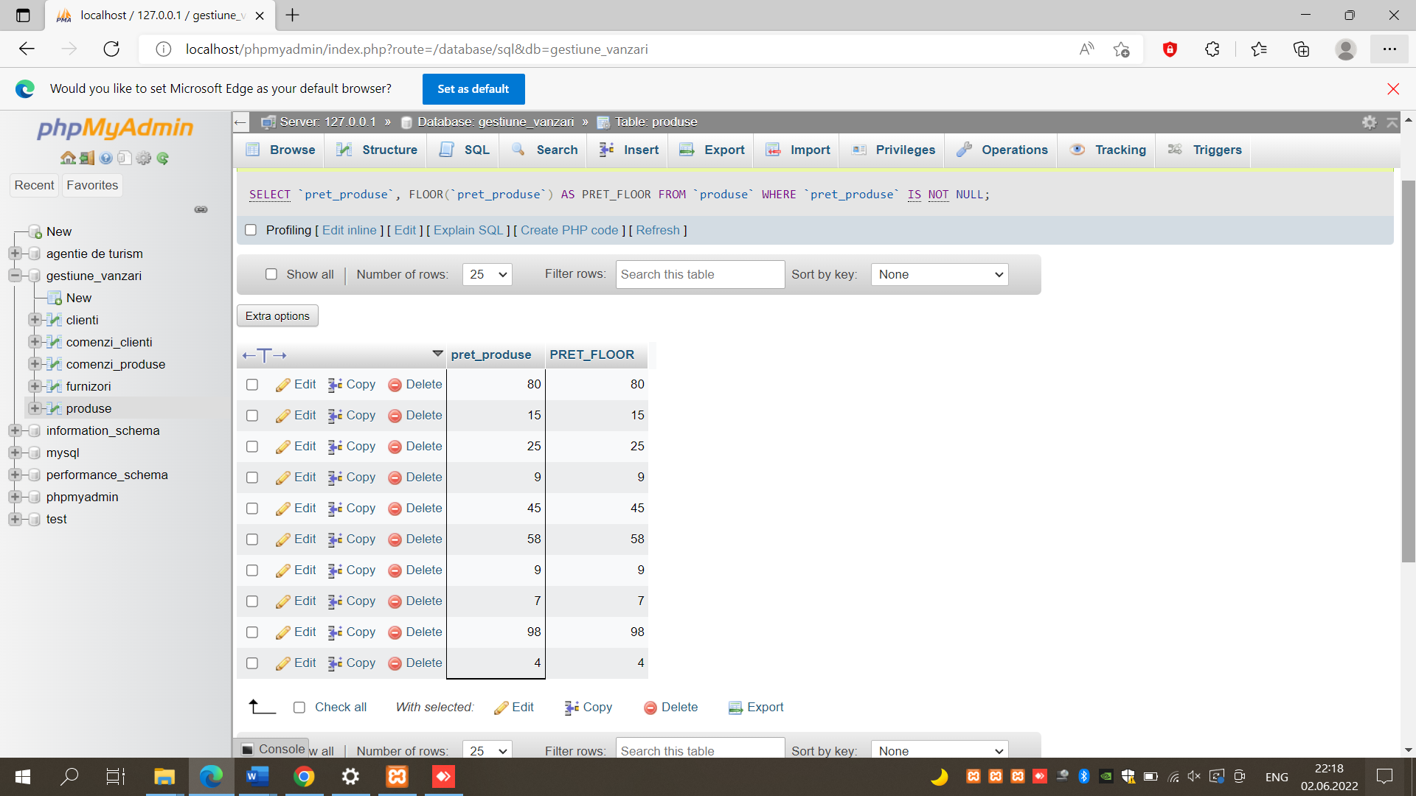

FUNCTIA CASE SIMPLA:

[SELECT](http://localhost/phpmyadmin/url.php?url=https://dev.mysql.com/doc/refman/8.0/en/select.html) `nume\_clienti`, `prenume\_clienti`, `varsta\_clienti`, [CASE](http://localhost/phpmyadmin/url.php?url=https://dev.mysql.com/doc/refman/8.0/en/control-flow-functions.html%23operator_case) `varsta\_clienti` WHEN `varsta\_clienti` = 25 THEN 'young' ELSE 'old' END as 'tip\_client' FROM `clienti`;

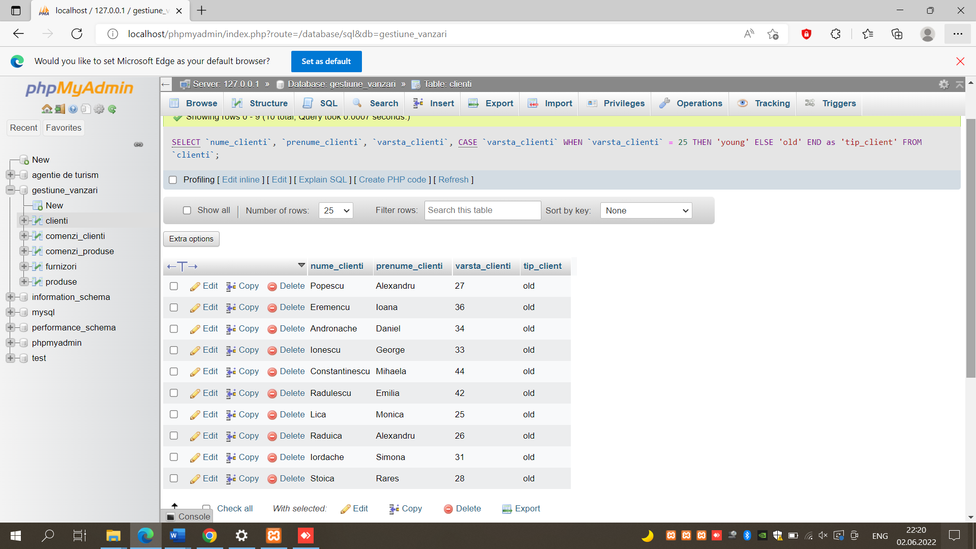

FUNCTIA CASE CU CAUTARE:

[SELECT](http://localhost/phpmyadmin/url.php?url=https://dev.mysql.com/doc/refman/8.0/en/select.html) `id\_produse`, `descriere\_produse`, `pret\_produse`, [CASE](http://localhost/phpmyadmin/url.php?url=https://dev.mysql.com/doc/refman/8.0/en/control-flow-functions.html%23operator_case) `pret\_produse` WHEN `pret\_produse` < 25 THEN 'IEFTIN' WHEN `pret\_produse` > 80 THEN 'SCUMP' WHEN `pret\_produse` <45 THEN 'IN BUGET' ELSE 'FOARTE SCUMP' END AS 'pret' FROM `produse`;